



Taizé February 4, 2018

A service of song, silence and contemplation

W i N K K

Worship in a New Key January 7, 2018

The People’s Preparation

“Silence is the sleep that nourishes wisdom.”

~ Francis Bacon

*Welcome to Taizé worship at WiNK. Please make yourself comfortable to pray, either sitting on a chair or the floor. We ask you to enter and leave the chapel in silence so that others may pray without interruption.*

*Central to Taizé worship is a focus on meditative singing. The words to the songs are generally few and simple so that when repeated many times over the music can be a way of both praying to and listening for God. Let the meditative repetition allow you to move beyond reading the words or enjoying the music to create a space to pray through song.*

*Another important aspect of Taizé worship is silence. Scripture readings are followed by long periods of silence to create an opportunity for personal reflection and meeting with God. Taizé worship often has a visual focal point, either a cross or icon, to remind us of the incarnation and the theological reality that the Creator of matter became manifest in matter for our sake. Should your mind wander, we invite you to use the cross as a visual focal point for your prayer.*

**Called**

*Let Us Praise Your Name*

*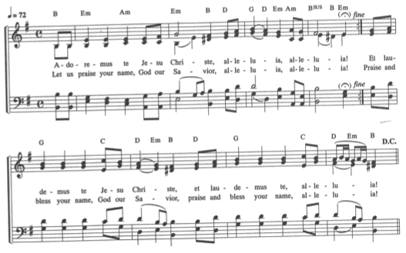*

**Silence**

*Da Pacem Cordium*

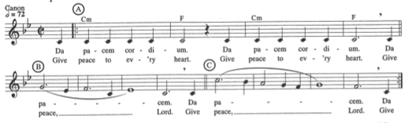

**Fed**

*First Reading - Psalm 103*

**Silence**

*In God Alone*

*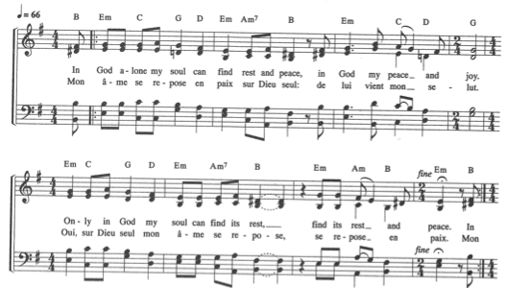*

*2nd Reading* **-** *Mark 10:17-22*

**Silence**

*Nada te Turbe*

*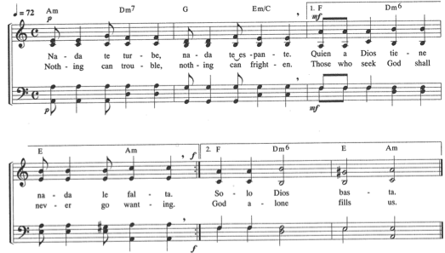*

**Silence**

*Prayers of the People - Candle Lighting – Offering*

During the singing of *Lord Jesus Christ*, offer your prayers by lighting a tea light and placing it on the cross.

At this time you may also place an offering in the basket on the table of the Lord’s Supper.

*Lord Jesus Christ*

**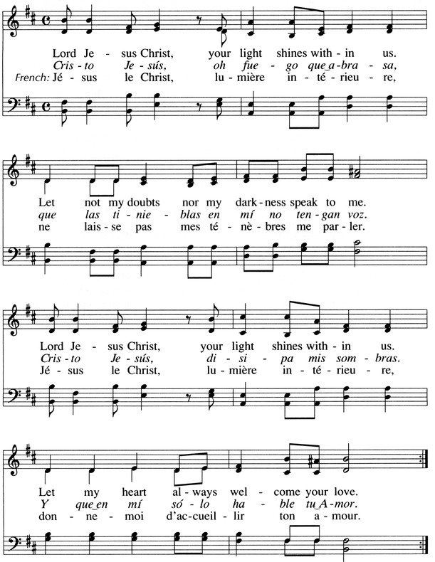**

**Silence**

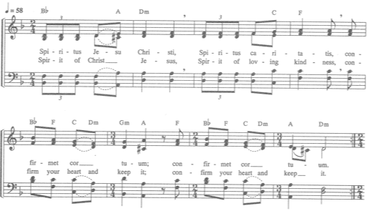

*The Lord’s Supper*

The Lord be with you.

**And also with you.**

Lift up your hearts.

**We lift them up to the Lord.**

Let us give thanks to the Lord our God.

**It is right to give our thanks and praise.**

...Therefore we praise you,

joining our voices with choirs of angels

and with the faithful of every time, tongue, and nation,

who forever sing to the glory of your name:

**Holy, holy, holy Lord, God of power and might;**

**Heaven and earth are full of your glory.**

**Hosanna in the highest.**

**Blessed is the one who comes in the name of the Lord.**

**Hosanna in the highest.**

Great is the mystery our of faith:

**Christ has died, Christ has risen, Christ will come again. Amen.**

Music during Communion

*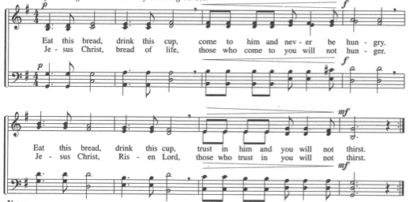*

*Prayer after Communion & the Lord’s Prayer (ecumenical version)*

|  |  |
| --- | --- |
| **Our Father in heaven,**  **hallowed be your name,**  **your kingdom come,**  **your will be done,**  **on earth as it is in heaven**  **Give us today our daily bread.** | **Forgive us our sins,**  **as we forgive those who sin against us.**  **Save us from the time of trial**  **and deliver us from evil.**  **For the kingdom, the power, and the glory are yours, now and for ever. Amen.** |

**Going out in Silence**

\*\*While we continue to sing *Spiritus Jesu Christi,* please stay as long as you wish to worship, pray, and meditate.

When you are ready, please leave the room quietly without disturbing those who are still meditating.

**Sent**

*Benediction*

*Spiritus Jesu Christi\*\**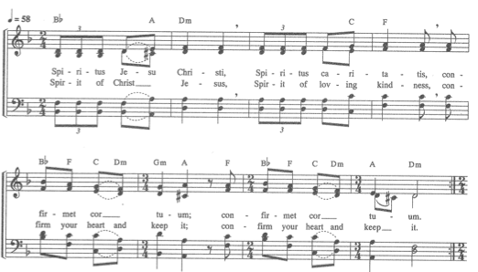

.

About Taizé

Taizé is a small village in France but the name has become synonymous with a particular style of Christian worship. Since the 1940’s a group of Christians (both Catholic and Protestant) have lived a simple, communal life in Taizé with the intention of being a community of prayer and a place of peace for human beings. Members of the community initially took in children orphaned by World War II and displaced Jews. These days the community receives a constant flow of visitors who make spiritual pilgrimage to Taizé to experience their unique style of meditative worship.



**WiNK** **Staff**

The Reverend Doctor Jeffrey A. Vamos

The Reverend Merideth Mueller

**WiNK** **Intern**

Julie Demaree

**Musician**

Arlo Ehly

**Visit us Online**

**Facebook:**

Worship in a New Key

at the

Presbyterian Church of Lawrenceville

**Our Mission:**

**Called, Fed, Sent.**

The Presbyterian Church

of Lawrenceville is a welcoming community,

**called** by God to be followers of Jesus Christ,

**fed** by the Word of God, &

**sent** by the Spirit into the world to live

lives of stewardship and service.

**Announcements**

**WiNK Greeters and Readers**

Calling all worshipers! The word *liturgy* is sometimes rendered"divine service” and refers to *“a formal ritual, which may or may not be elaborate, enacted by those who understand themselves to be participating in a divine action.”* Are you being called to be a liturgist? Sign up this evening to enrich your experience and deepen the journey. No experience necessary.

**Arm in Arm Ministry**

As we depart from WiNK each Sunday, we are charged to go into the world to share the Good News. Our own special ministry is to 26 low-income senior citizens in the Trent Center Senior Complex on Greenwood Avenue, providing home food delivery once a month (Feb.10, March 10, April 14 ). We meet at the church at 9:30 and return by 11:30 am. We need 4-6 volunteers each month to deliver bags of food. Everyone can help: children, youth, adults and seniors. To sign up, contact Marcia MacKillop at marciakp5560@gmail.com or text/call (609)672-6668.

**The Power of Purpose**

The Community Well believes "that the human spirit's deepest yearning is actually to serve; to be used for some greater purpose." Join us for *The Power of Purpose* (POP) on Sunday evenings during Lent. Learn how to ground all you do with what is most meaningful and important to you. Let go of what isn't working so you are free to serve without unwanted stress. Join PTS intern Julie Demaree on Sundays after WiNK, 6:30-8:30pm, Feb 18, 25, Mar 4, 11, 18, and 25. $35 Materials fee. $90 Tuition. Scholarships available. Enrollment open to 12 participants, minimum of 6.  Registration deadline Feb. 11.

Email [julie.demaree@ptsem.edu](mailto:julie.demaree@ptsem.edu" \t "_blank) for registration form and/or more information.

**Child Care**

Child care is available this week and every week in the nursery off of Fellowship Hall. Please ask the greeter or a WiNK staff person to show you the way.

**Cover Art**

*Photo by Jim Block*

W i N K K

**Worship in a N ew K ey**

**December 10, 2017**

**The Presbyterian Church of Lawrenceville**